THE CHLOR-ALKALI INDUSTRY
Chlorine is manufactured by the electrolysis of brine (saturated sodium chloride solution).
The overall reaction is:
2NaCℓ (aq) + 2H₂O(ℓ) → Cℓ ₂(g) + H₂(g) + 2NaOH(aq)
There are three different cells:
- Mercury cell
- Diaphragm cell
- Membrane cell
The mercury cell uses the least energy of the three cells but it has the lowest yield of chlorine. Mercury is also harmful to the environment.
The diaphragm cell produces a dilute sodium hydroxide solution and it uses an asbestos diaphragm, which is also harmful to the environment.
The membrane cell: LEARN WELL!!!
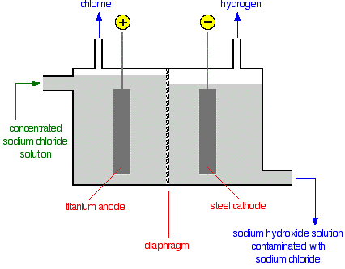

The membrane used is a polymer, which is quite expensive to make but it has no harmful environmental issues. This method produces very pure sodium hydroxide.
NITROGEN GAS
Nitrogen occurs naturally in the atmosphere. It forms 78% of the air. Pure nitrogen is obtained by from the fractional distillation of liquid air.
HYDROGEN GAS
Hydrogen gas is produced at Sasol from steam and coal by the process of gasification. These are heated together with oxygen at very high temperatures and pressure.

Aluminium Extraction
Aluminium is mine as an ore called Bauxite which is washed by NaOH to produce alumina (Al₂O₃) and mostly Fe₂O₃ which is known as read mud. Then aluminium has to be separated from oxygen during extraction. The bauxite has to be made molten before it can start conducting electricity. However, Al₂O₃ melts at 2050◦C which requires a lot of energy that is generated from electricity. These temperatures consume lot of energy and that may lead to less profit being obtained. Therefore, alumina is dissolved is cryolite (Na₃AlF₆) which reduces the melting point temperature of alumina to 900 – 1000 ◦C. This invention is cost effective because the amount of electricity used is reduced by more than half. Also this help in reduction of CO₂ on electricity production of which it’s also an environmental saving measure. Since CO₂ is a greenhouse gas. The aluminium extraction cell uses carbon electrodes (both anode and Cathode). After alumina has been electrolyzed it produces Al³⁺ and O²⁻; of which Al³⁺ is attracted by a negative electrode which is a cathode and it undergoes reduction there. Whereas O²⁻ is attracted by a positive electrode which is an anode and it get oxidized there. The reactions occurring in this cell are as follows:
Anode: 2O²⁻ → O₂ + 4e⁻
Cathode: Al³⁺ + 3e⁻ → Al
Nett: 4Al³⁺ + 6O²⁻ → 4Al + 3O₂
However the production of O₂ at the Carbon anode may lead to a side reaction which reduces the size of this electrode.
That side reaction C + O₂ → CO₂. This CO₂ re-joins the environment. Therefore, after sometime anode may need to be replaced.
The diagram below shows the simple representation of aluminium extraction cell.
Pure Al

SUMMARY OF ELECTROLYTIC CELL VS VOLTAIC (GALVANIC) CELL
 | ELECTROLYTIC | VOLTAIC (GALVANIC)
Appearance of simple form of cell | 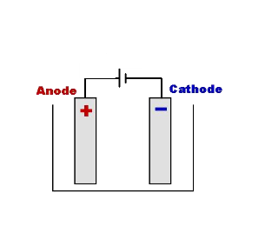  - Must have cell or battery in external circuit to supply electrical energy.  - Consists of 2 electrodes in the SAME solution. | V  KNO₃ _{(aq)}  salt bridge  electrons  electrons  Anode (-)  Cathode (+)  Ions  - No external source of electricity i.e. there will be no cell or battery shown in the external circuit.  - It consists of two half cells containing different electrodes each of which is in a solution of its salt. The solutions in each half cell are DIFFERENT.  - There must either be a salt bridge or some sort of porous membrane separating the two half cell to allow for the passage of ions between cells.
Energy conversion | Electrical to chemical | Chemical to electrical
Polarity of electrodes | Anode = positive  Cathode = negative | Anode = negative  Cathode = positive
Uses | Extraction of aluminium; purification of copper; electroplating;  chlor-alkali process – electrolysis of brine to form chlorine, sodium hydroxide and hydrogen | Batteries  - Primary – zinc-carbon; lithium; mercury (not rechargeable)  - Secondary – lead-acid accumulator or car battery (rechargeable)

QUESTION 1: DBE Exemplar 2014
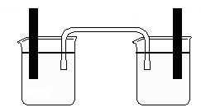
The voltaic cell represented below functions at standard conditions.
V

graphite
graphite
I₂ (s)
H⁺ (aq)
MnO₄⁻ (aq), Mn²⁺ (aq)
I⁻ (aq)

1.1 Write down the concentration of H⁺ (aq) in the one half-cell. (1)
1.2 Solids present in half-cells are usually used as electrodes. Give a reason why
I₂(s) is not suitable to be used as an electrode. (1)
1.3 Write down TWO properties of graphite, other than being a solid, that makes it
suitable for use as electrodes in the above voltaic cell. (2)
1.4 For the above voltaic cell, write down the :
1.4.1 NAME of the oxidizing agent. (1)
1.4.2 Net cell reaction (3)
1.4.3 Cell notation (3)
1.5 Calculate the cell potential of the above cell. (4)
1.6 How will the reading on the voltmeter be affected if the concentration of MnO₄⁻
decreases? Only write down INCREASES, DECREASES or NO EFFECT. (1)

